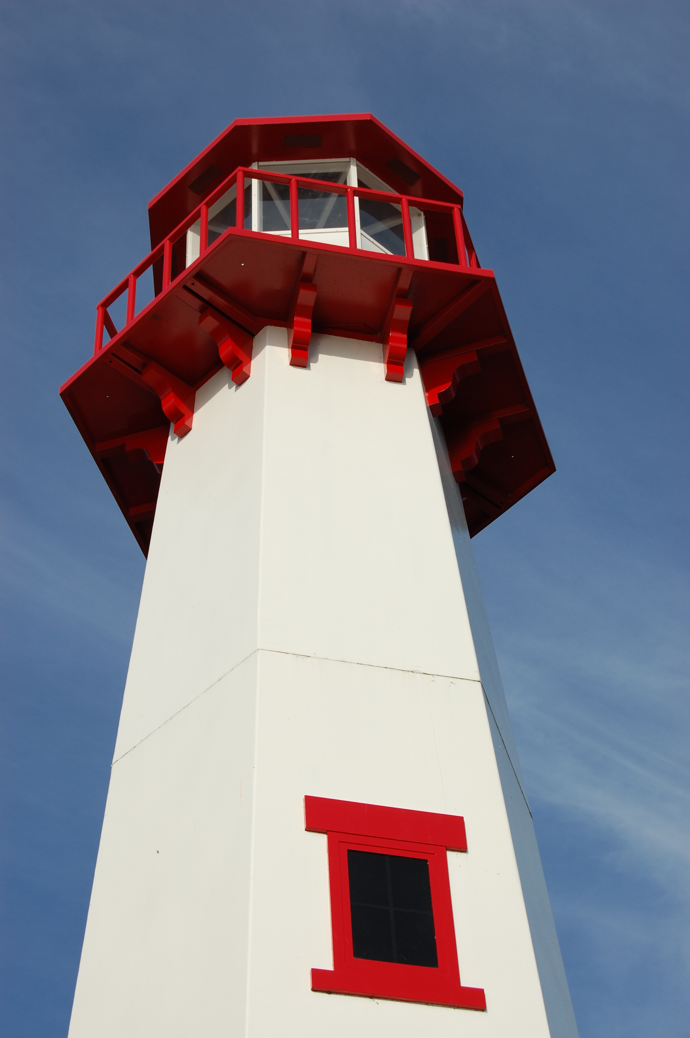
THE LIGHTHOUSE

Newsletter for June 2018

Your word is a lamp to my feet and
a light for my path. Psalm119:105

Message from Our Pastor

Dear Sisters and Brothers in Christ,

There it was, something that I haven’t seen in a few months. It was purple and white and it looked absolutely amazing! It was a small flower in the planter, sadly I have no idea what kind of flower it is, but that didn’t take away from all its God given glory as the colors popped in the sunlight!

I love the renewal of spring, there is something about seeing colors where all you have seen is white, you notice the sunshine, and the birds singing; even the rain on the window has a beautiful sound to it. Even Lake Huron is really making sure I hear it as I write this newsletter article!

It’s also good seeing life pick up in our communities, the darkened windows of businesses are being lit up again as they open for spring and summer. I am beginning to see new faces of visitors and the familiar faces of members returning from the south, and that warms my heart.

I also realize it’s a time when things can slow down at church, with summer many people have extra jobs, and of course it’s time to go on vacation. From life experience I also know, spring can be a difficult time for some. The renewal in the world around us may not be felt inside us. It’s in these times when we need to hear Christ is walking with us the most. Thankfully even though things might have seemed to have slowed down for us, as a community of faith, in so many ways it hasn’t. We are still here welcoming you to join us every Sunday for worship!

Yours in Christ,
Pastor David

Letter from the Council

May 21, 2018

Dear Zion Congregational Members.

In a recent newsletter to member churches of the Northern Great Lakes Synod, Bishop Finnegan talked about the challenges facing many churches today. She talked about increased anxiety about paying church bills, decline in worship attendance, fewer youth and smaller Sunday Schools, fewer new members, and for some a fear of closing if not soon then in a few years.

On May 16, Zion Church Council met, and we talked about how Zion is facing some of the same issues and challenges that the Bishop highlighted, and that we as a congregation need to address them a bit more actively. So far we have largely met our bills and responsibilities, but we are slipping towards a negative balance in the Church Budget in spite of fund raisers such as pasty sales, soup luncheons, and craft fairs. Our membership has been declining. The Council has been concerned about these trends for some time, and we want to more fully inform all of you, and together as a Congregation come up with some potential solutions to these challenges.

So how do we do this? The first and most obvious way is to add to our church membership so there are more people to help shoulder church obligations. Ask people you know to come and see what our church offers. Tell people with kids about our Sunday School, Confirmation, and NOIZ group, and invite them to check it out. If you are able, increase your weekly giving or offer a one time financial gift or a service gift.

"If one member suffers, all suffer together with it, if one member is honored, all rejoice with it!" 1 Corinthians 12, v. 26.

A second way is to offer more choice in church service times to those who might attend. To that end, Church Council decided that for 3 Saturdays starting July 7, Zion will be offering a Saturday night service at 6 pm for those unable to attend Sunday Service. There will be more to come on this.

A third way is to reduce costs where we can. Recently we installed new LED lights downstairs and it resulted in some nice savings in energy costs. Zion is offering a chance to "buy an LED light bulb for upstairs” to further help reduce energy costs in the Church. There is a sign up sheet in the Family Life area in the Church if you wish to participate in this.

The Council will keep attention on these matters over the next month.

At our next Council meeting on June 13, we will discuss and decide if we need to call a full congregational meeting in July to discuss and decide as a congregation what additional steps might be necessary. We will keep you informed, and please, please, discuss any membership, fund raising, or cost cutting ideas you may have with Pastor, or any Council Member (Dena Barker, Mary Christiansen, Tammy Shepard, Bob Marshall, Carol Elmblad, Emma Feleppa, or Steve Christiansen).

Remember, we are not alone in this. Please include these challenges in your prayers and thoughts and potential solutions may become evident to you.

"God of all, help us to see what parts we play, and find our places where we can best serve you!"

Stevan Christiansen
Zion Council President

Newsletter

The Newsletter was adopted by Jackie Dell


In loving memory of her husband

Donald Dell

Noisy Offering

The June Noisy Offering will go to Feed America Truck

Adult Bible Study

Trinity Bible Study will be Tuesdays at 6 pm.

Zion Bible Study will be Wednesdays at 7 pm.

Long-Term Care

Evergreen Living Center:
Barb Lehto
Judy Ryerse
Mid-Summer Pole Raising

Trinity will be having their annual Mid-summer Pole Raising on June 17th. Tying leaves will start at 2:00 pm followed by the pole raising. The Pot luck luncheon will start at 4:00 p.m.
Everyone is welcome!

Let Your Light Shine

Adopt a light bulb to help save money on our
electric bill. We are changing to LED bulb
and should save about $300 a year. There are
8 to change out at $50 @ and 30 to change out
at $10 @. Can you help purchase a bulb?

Birthdays in June

Michael Lennington 5
Carol Richel 5
Kennedy Music 6
Jeff Gamble 8
Eunice Therrian 9

Audrey Stenson 10
Gayle Lamoreaux 13
Zachery Bigger 14
Sheridan Bigger 19
Nick Schlehuber 21
Abby LaLonde 22
Mark Elmblad 27
David LaVake 30
Samantha LaVake 30

June Wedding Anniversaries

John & Jane Chambers 6
Mike & Jodi Gustafson 12
Paul & Tammy Shepard 19
Ivan & Karen Schlehuber 20
Gary & Monica Sorenson 27

June Baptismal Anniversaries

Ryan Marshall 1

Ben Idalski 11
Bill Harju 13
Joel Dodds 18
Cara St. Andrew 20
Ben Doran 20
Ethan Shepard 22
Karen Schlehuber 23

Prayer List

If you would like someone added to the prayer list, please fill out a yellow card or call the church)

Mary Belonga, Dave & Lois Movalson, Barb Lehto, Bev Kammers, Eunice Therrian, Craig Therrian, Shirley Winberg, Richard Galor, Judy Ryerse, Cindy Hendricks, Carol Litzner, Holly Lester, Sandy Huskey, Jim & Jerri Rose, Bill & Sandy Tielbar, Walter & Jane Puccio, Carol & John Watson, Mike & Linda Wilkins, Larry Hopper, David Lloyd, Donna Harju, Tom Beaudoin, Terri Hill, Merlin Doran (Merlin’s father), Gayle Kaminsky Pande, Ann Blaine, Mary Ellen Reavie, Sylvia Richards, Jackie Jacobson, Deb Tamlyn, Krista MacArthur, Donna Harju and Joe

Servants for Zion

Ushers & Greeters

June 3 Stevan & Mary Christiansen
June 10 Cathie & Ellie Tielbar
June 17 Andrea Insley & Tina Schlehuber
June 24 NOIZ

Lectors

June 3 Betsy Turf
June 10 Sandy Feleppa
June 17 Fred Feleppa
June 24 NOIZ

Communion Assistants

June 3 Mary Christiansen
June 10 Carol Elmblad
June 17 Emma Feleppa

Acolytes

June 3 Gunnar Olsen
June 10 Brendan Insley
June 17 Josh Feleppa

Altar: Cathie Tielbar
Money Counters: Dena Barker & Lana Lennington

The Usher duties are:
- Arrive 30 minutes before church
- Pass out bulletins and welcome guests
- Help with the offering and communion
- Record attendance

We will be providing the Long Term Care Service on June 10th. Please help out if you can.

Zion Funeral Committee June-Sept

Team Leader: Lorraine Graham (643-8419)
Co-leader: Betsy Turf (643-1512)

Trinity Worship Families

June 3 Kennedy Family
June 10 Rose Family
June 17 Movalson Family
June 24 Baron Family

Contact Information

Pastor David Tielbar may be reached at 906-984-2051 or at david.tielbar6@gmail.com. In an emergency, you can reach the Pastor’s cell phone at (563) 880-4512

Church telephone: 906-643-7870 - Answering machine
The secretary will usually be in the office on Tuesday and Thursday mornings from 9 – 12

The website is at http://zionstignace.com/home.html
- Find us on facebook at www.facebook.com/zionstignace

Email: ziontrinity950@gmail.com

Zion Evangelical Lutheran Church and Trinity Lutheran Church are congregations of the Northern Great Lakes Synod and the Evangelical Lutheran Church in America.

Trinity’s Sunday Service is at 9 a.m.
Zion’s Sunday Service is at 11 a.m.

Treasurer's Report for Zion
January 1, 2018 through May 23, 2018
Income:
 | Amazon Smile Foundation | 14.79
 | Building | 25.00
 | Church Use Income | 500.00
 | General | 20,583.44
 | Fund Raising | 2,519.77
 | Trinity Share | 4,455.57
 | TOTAL |  | 28,098.57
Expenses:
 | Administration | 2,445.56
 | Benevolence | -122.03
 | Church Maintenance | 4,971.51
 | Education | 285.45
 | Parsonage Maintenance | 1,448.03
 | Pastoral | 19,430.30
 | Worship | 1,401.54
 | --To Building Fund | 0.00
 |  |  | 29,860.36
 |  |  | -1,761.79
***********************************************************
Thrivent Financial Investment Fund |  |  | 330.31
General fund balance: |  |  | 1390.75
Kitchen/Building Fund balance |  |  | 1376.85
General fund owes building fund: |  |  | $ -
General fund owes Mission Endowment fund: |  |  | $ 7,995.00

Trinity Lutheran Church

Council Meeting Minutes
May 15, 2018

Present: Pastor Dave, Jerri and Jim Rose, Pega and John Kennedy, Tracy Movalson, Lois Movalson and Tom Gustafson

Meeting began at 6:17pm

Opening: Pastor read Psalm 11 Lord in your Name give Glory

Pastors Report: Getting ready for Youth Gathering in Houston June 2018. Going to Iowa for Thanksgiving.

Secretary’s Report was read and approved.

Treasurer’s Report was read and approved.

Financial Secretary’s Report not available.

Old Business:

Tracy motioned we install gutters, Tom Supported. Approval to install new gutters

Midsummer Pole Lyncher? Tom will ask our candidate if he accepts.

New Business

We will take an oﬀering to Synod Assembly.

Discussion on midsummer pole preparations.

Lions Club will meet here October 8 for dinner meeting.

Meeting adjourned at 6:49pm

Respectfully Submitted,

Tracy Movalson, Secretary

Council Meetings

Zion Council – June 13, 6:30 pm

Trinity Council – June 19, 6 pm

Zion’s Council Members
President: Steve Christiansen 298-1051
Vice-President: Carol Elmblad 630-4380
Co-Treasurers: Dawn Akers 643-7552
Co-Treasurers: Lana Lennington 643-6576
Mary Christiansen 235-6123
Robert Marshall 643-8936
Secretary Dena Barker 430-1460
Emma Feleppa 430-8011
Tammy Shepard 906-984-2064

Trinity’s Council Members
President: Jerri Rose 292-5570
Vice-President Sharon Chalmers 292-5440
Secretary: Tracy Movalson 292-5581
Treasurer: Pega Kennedy 292-5633
Co-Treasurer: Jim Rose 292-5570
Financial Secretary: Tom Gustafson 292-5460
WELCA: Pega Kennedy 292-5633
John Kennedy 292-5633
Lois Movalson 292-5581

~~~~~~~~


A father is someone you can look up to,
no matter how tall you get.
Happy Father’s Day!

